2. Host a FTP and SFTP server and try PUT and GET operations.

FTP:

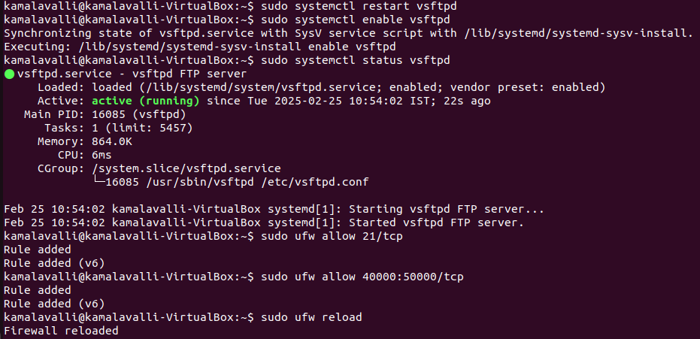

LOG IN TO FTP

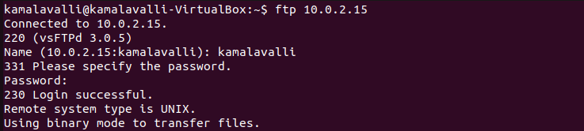

FTP - PUT

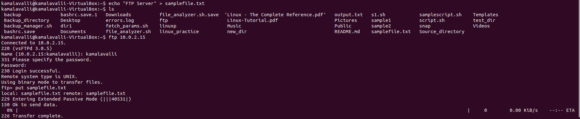

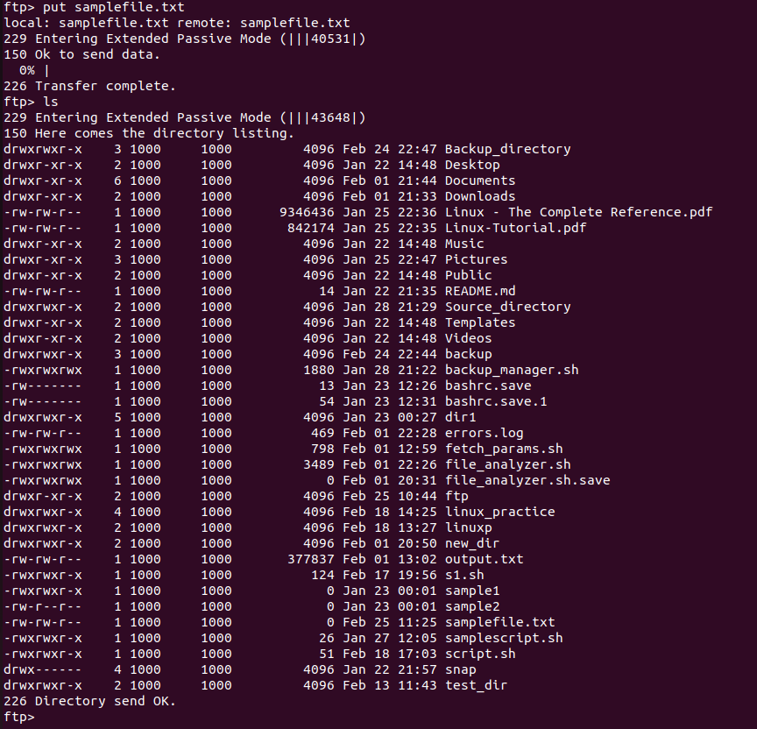

FTP – GET

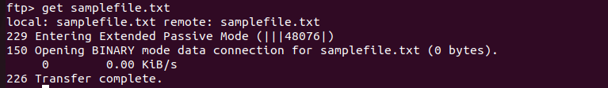

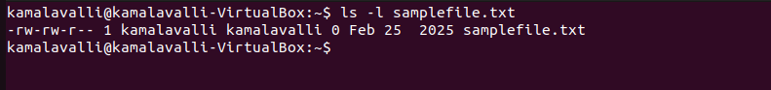

SFTP:

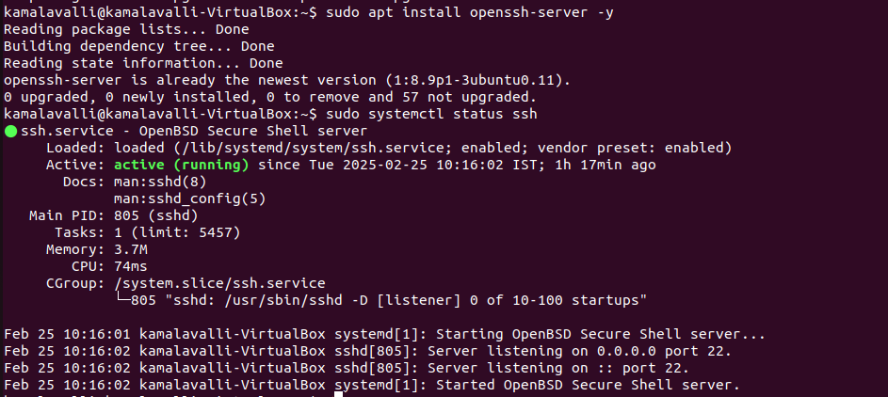



SFTP PUT:

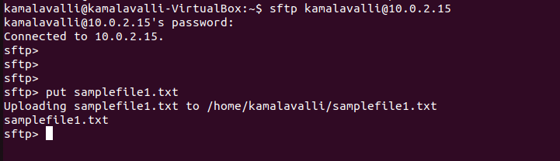

SFTP GET:

